Stat400-Assignment1

2024-02-06

## R Markdown

This is an R Markdown document. Markdown is a simple formatting syntax for authoring HTML, PDF, and MS Word documents. For more details on using R Markdown see <http://rmarkdown.rstudio.com>.

When you click the **Knit** button a document will be generated that includes both content as well as the output of any embedded R code chunks within the document. You can embed an R code chunk like this:

summary(cars)

## speed dist   
## Min. : 4.0 Min. : 2.00   
## 1st Qu.:12.0 1st Qu.: 26.00   
## Median :15.0 Median : 36.00   
## Mean :15.4 Mean : 42.98   
## 3rd Qu.:19.0 3rd Qu.: 56.00   
## Max. :25.0 Max. :120.00

## Including Plots

You can also embed plots, for example:

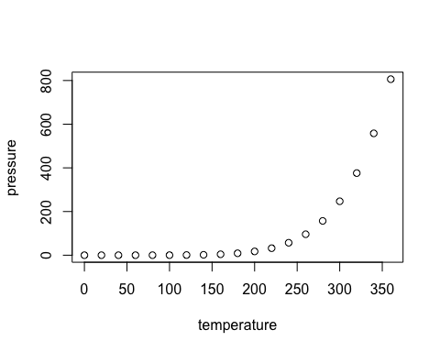

Note that the echo = FALSE parameter was added to the code chunk to prevent printing of the R code that generated the plot.

cars <- read.csv(file="cars.txt", stringsAsFactors =  
FALSE)  
cars2 <- read.csv(file="cars2.txt", stringsAsFactors =  
FALSE)

cars_tiny <- cars[1:5,c(1, 3, 4, 8)]  
cars_tiny

## mpg cubicinches hp brand  
## 1 14.0 350 165 US.  
## 2 31.9 89 71 Europe.  
## 3 17.0 302 140 US.  
## 4 15.0 400 150 US.  
## 5 30.5 98 63 US.

cars_tiny[2,2] <- cars_tiny[4,4] <- NA  
cars_tiny[2,2] <- 0  
cars_tiny[4,4] <- "Missing"  
cars_tiny

## mpg cubicinches hp brand  
## 1 14.0 350 165 US.  
## 2 31.9 0 71 Europe.  
## 3 17.0 302 140 US.  
## 4 15.0 400 150 Missing  
## 5 30.5 98 63 US.

hist(cars$mpg)

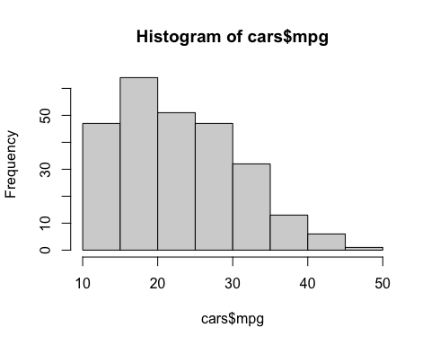

boxplot(cars$cubicinches)

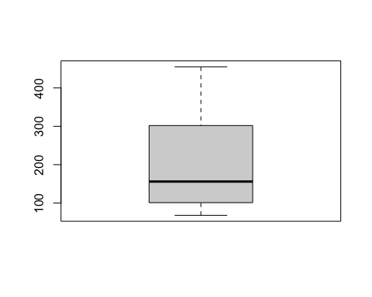

plot(cars$mpg, cars$cubicinches)

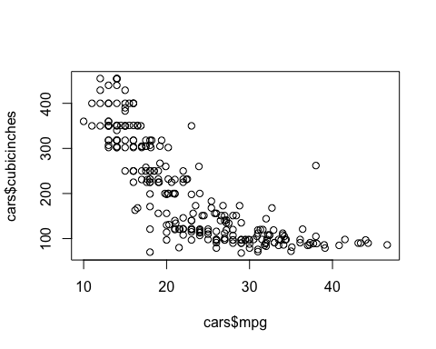

mmnorm.weight <- (cars$weight - min(cars$weight))/(max(cars$weight) - min(cars$weight))  
mmnorm.weight

## [1] 0.76713948 0.09219858 0.54255319 0.63475177 0.12943262 0.67582742  
## [7] 0.81264775 0.79757683 0.56648936 0.12913712 0.18676123 0.16991726  
## [13] 0.74704492 0.60608747 0.52245863 0.81176123 0.12027187 0.53782506  
## [19] 0.19651300 0.24143026 0.11997636 0.29166667 0.41341608 0.72133570  
## [25] 0.10490544 0.05378251 0.04728132 0.89952719 0.57949173 0.22665485  
## [31] 0.15277778 0.49202128 0.26388889 0.30585106 0.10992908 0.53250591  
## [37] 0.06560284 0.32712766 0.69208038 0.48817967 0.67494090 0.89391253  
## [43] 0.60047281 0.56353428 0.43528369 0.30200946 0.63297872 0.23108747  
## [49] 0.09663121 0.42760047 0.84249409 0.46601655 0.58983452 0.16105201  
## [55] 0.81767139 0.78752955 0.38918440 0.13652482 0.09574468 0.65248227  
## [61] 0.39361702 0.22635934 0.38327423 0.14686761 0.77541371 0.56501182  
## [67] 0.09958629 0.10401891 0.06264775 0.66991726 0.44001182 0.30348700  
## [73] 0.19946809 0.27541371 0.17907801 0.41430260 0.43498818 0.26654846  
## [79] 0.19267139 0.21778960 0.80141844 0.98670213 0.53546099 0.31944444  
## [85] 0.17937352 0.00000000 0.34308511 0.54728132 0.15130024 0.32712766  
## [91] 0.10697400 0.20301418 0.73492908 0.50709220 0.18971631 0.67789598  
## [97] 0.85283688 0.45094563 0.65514184 0.64066194 1.00000000 0.97310875  
## [103] 0.15159574 0.17346336 0.19267139 0.30200946 0.21335697 0.13356974  
## [109] 0.31264775 0.55880615 0.19680851 0.39007092 0.80437352 0.05378251  
## [115] 0.15277778 0.64184397 0.33303783 0.42139480 0.12765957 0.80614657  
## [121] 0.17405437 0.10342790 0.90277778 0.33451537 0.06530733 0.28132388  
## [127] 0.89864066 0.18232861 0.28634752 0.05526005 0.20301418 0.31471631  
## [133] 0.98640662 0.60845154 0.83540189 0.76152482 0.10106383 0.45981087  
## [139] 0.39361702 0.40366430 0.32121749 0.16489362 0.31087470 0.04343972  
## [145] 0.58865248 0.39716312 0.51625296 0.33156028 0.61465721 0.47044917  
## [151] 0.27452719 0.27984634 0.83096927 0.45656028 0.25147754 0.49911348  
## [157] 0.15100473 0.15425532 0.30171395 0.53102837 0.41075650 0.72901891  
## [163] 0.40514184 0.38150118 0.18942080 0.51773050 0.53959811 0.28723404  
## [169] 0.35283688 0.15130024 0.20005910 0.35963357 0.07505910 0.28427896  
## [175] 0.18114657 0.17021277 0.81914894 0.60845154 0.57830969 0.12765957  
## [181] 0.40691489 0.15721040 0.76891253 0.53871158 0.23108747 0.43055556  
## [187] 0.54550827 0.68764775 0.74349882 0.92257683 0.29757683 0.31235225  
## [193] 0.83008274 0.72960993 0.72813239 0.15691489 0.25916076 0.10992908  
## [199] 0.09574468 0.09810875 0.18705674 0.30319149 0.53398345 0.59604019  
## [205] 0.23286052 0.66105201 0.14686761 0.41607565 0.73433806 0.38031915  
## [211] 0.35520095 0.54137116 0.04196217 0.13622931 0.47872340 0.29609929  
## [217] 0.10697400 0.76891253 0.29018913 0.79255319 0.46690307 0.34929078  
## [223] 0.84042553 0.65218676 0.71778960 0.11524823 0.88711584 0.01063830  
## [229] 0.28782506 0.34781324 0.57624113 0.29905437 0.28930260 0.85254137  
## [235] 0.45419622 0.15277778 0.73374704 0.39952719 0.07742317 0.17937352  
## [241] 0.72163121 0.44562648 0.77039007 0.31294326 0.80998818 0.52777778  
## [247] 0.62706856 0.13947991 0.16016548 0.26950355 0.14982270 0.30939716  
## [253] 0.39509456 0.70183215 0.32860520 0.22429078 0.65809693 0.05526005  
## [259] 0.36111111 0.49497636 0.51418440

zscore.weight <- (cars$weight - mean(cars$weight))/sd(cars$weight)  
zscore.weight

## [1] 1.411500375 -1.267221019 0.520157004 0.886076914 -1.119445671  
## [6] 1.049098925 1.592114690 1.532300858 0.615155442 -1.120618491  
## [11] -0.891918547 -0.958769300 1.331748600 0.772313352 0.440405229  
## [16] 1.588596229 -1.155803098 0.501391880 -0.853215480 -0.674946806  
## [21] -1.156975918 -0.475567367 0.007634565 1.229713240 -1.216789750  
## [26] -1.419687649 -1.445489694 1.936923836 0.666759532 -0.733587817  
## [31] -1.026792873 0.319604745 -0.585812469 -0.419271997 -1.196851806  
## [36] 0.480281116 -1.372774840 -0.334828940 1.113604038 0.304358082  
## [41] 1.045580465 1.914640252 0.750029768 0.603427240 0.094423262  
## [46] -0.434518660 0.879039993 -0.715995514 -1.249628716 0.063929936  
## [51] 1.710569532 0.216396565 0.707808240 -0.993953907 1.612052634  
## [56] 1.492424971 -0.088536693 -1.091297986 -1.253147177 0.956446128  
## [61] -0.070944390 -0.734760637 -0.111993098 -1.050249278 1.444339341  
## [66] 0.609291341 -1.237900514 -1.220308210 -1.384503042 1.025642521  
## [71] 0.113188386 -0.428654558 -0.841487278 -0.540072480 -0.922411873  
## [76] 0.011153026 0.093250442 -0.575257087 -0.868462143 -0.768772424  
## [81] 1.547547521 2.282905802 0.492009318 -0.365322266 -0.921239053  
## [86] -1.633140930 -0.271496648 0.538922127 -1.032656974 -0.334828940  
## [91] -1.208580008 -0.827413435 1.283662970 0.379418577 -0.880190345  
## [96] 1.057308667 1.751618240 0.156582734 0.967001510 0.909533319  
## [101] 2.335682713 2.228956072 -1.031484154 -0.944695458 -0.868462143  
## [106] -0.434518660 -0.786364727 -1.103026188 -0.392297131 0.584662116  
## [111] -0.852042660 -0.085018232 1.559275723 -1.419687649 -1.026792873  
## [116] 0.914224600 -0.311372536 0.039300711 -1.126482592 1.566312645  
## [121] -0.942349817 -1.222653851 1.949824858 -0.305508435 -1.373947660  
## [126] -0.516616075 1.933405375 -0.909510851 -0.496678131 -1.413823548  
## [131] -0.827413435 -0.384087390 2.281732982 0.781695914 1.682421847  
## [136] 1.389216791 -1.232036413 0.191767341 -0.070944390 -0.031068502  
## [141] -0.358285345 -0.978707244 -0.399334053 -1.460736357 0.703116959  
## [146] -0.056870547 0.415776004 -0.317236637 0.806325139 0.233988869  
## [151] -0.543590941 -0.522480176 1.664829544 0.178866318 -0.635070918  
## [156] 0.347752431 -1.033829795 -1.020928772 -0.435691480 0.474417015  
## [161] -0.002920817 1.260206566 -0.025204401 -0.119030019 -0.881363165  
## [166] 0.421640105 0.508428802 -0.493159671 -0.232793581 -1.032656974  
## [171] -0.839141637 -0.205818716 -1.335244593 -0.504887873 -0.914202132  
## [176] -0.957596480 1.617916735 0.781695914 0.662068251 -1.126482592  
## [181] -0.018167480 -1.009200570 1.418537296 0.504910341 -0.715995514  
## [186] 0.075658138 0.531885206 1.096011734 1.317674757 2.028403814  
## [191] -0.452110963 -0.393469952 1.661311083 1.262552206 1.256688105  
## [196] -1.010373390 -0.604577592 -1.196851806 -1.253147177 -1.243764615  
## [201] -0.890745727 -0.429827379 0.486145217 0.732437465 -0.708958592  
## [206] 0.990457914 -1.050249278 0.018189947 1.281317330 -0.123721300  
## [211] -0.223411019 0.515465723 -1.466600458 -1.092470806 0.266827835  
## [216] -0.457975064 -1.208580008 1.418537296 -0.481431469 1.512362914  
## [221] 0.219915026 -0.246867424 1.702359791 0.955273307 1.215639397  
## [226] -1.175741042 1.887665386 -1.590919402 -0.490814030 -0.252731525  
## [231] 0.653858510 -0.446246862 -0.484949929 1.750445420 0.169483756  
## [236] -1.026792873 1.278971690 -0.047487985 -1.325862031 -0.921239053  
## [241] 1.230886060 0.135471970 1.424401398 -0.391124311 1.581559308  
## [246] 0.461515993 0.855583588 -1.079569783 -0.997472368 -0.563528884  
## [251] -1.038521076 -0.405198154 -0.065080289 1.152307105 -0.328964839  
## [256] -0.742970379 0.978729712 -1.413823548 -0.199954614 0.331332948  
## [261] 0.407566262

mean(cars$mpg)

## [1] 23.14483

sd(cars$mpg)

## [1] 7.82357

min(cars$mpg)

## [1] 10

max(cars$mpg)

## [1] 46.6